**7-2: Project Two Submission README**

When the app is loaded, you land on this screen (Reset is selected):  
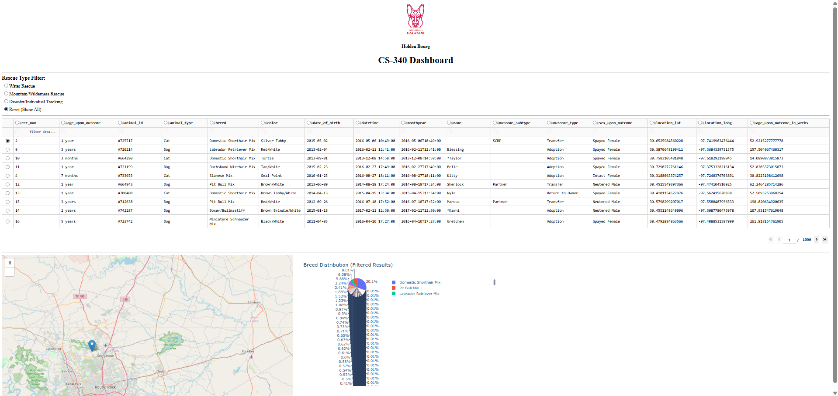

When Water Rescue is selected:  
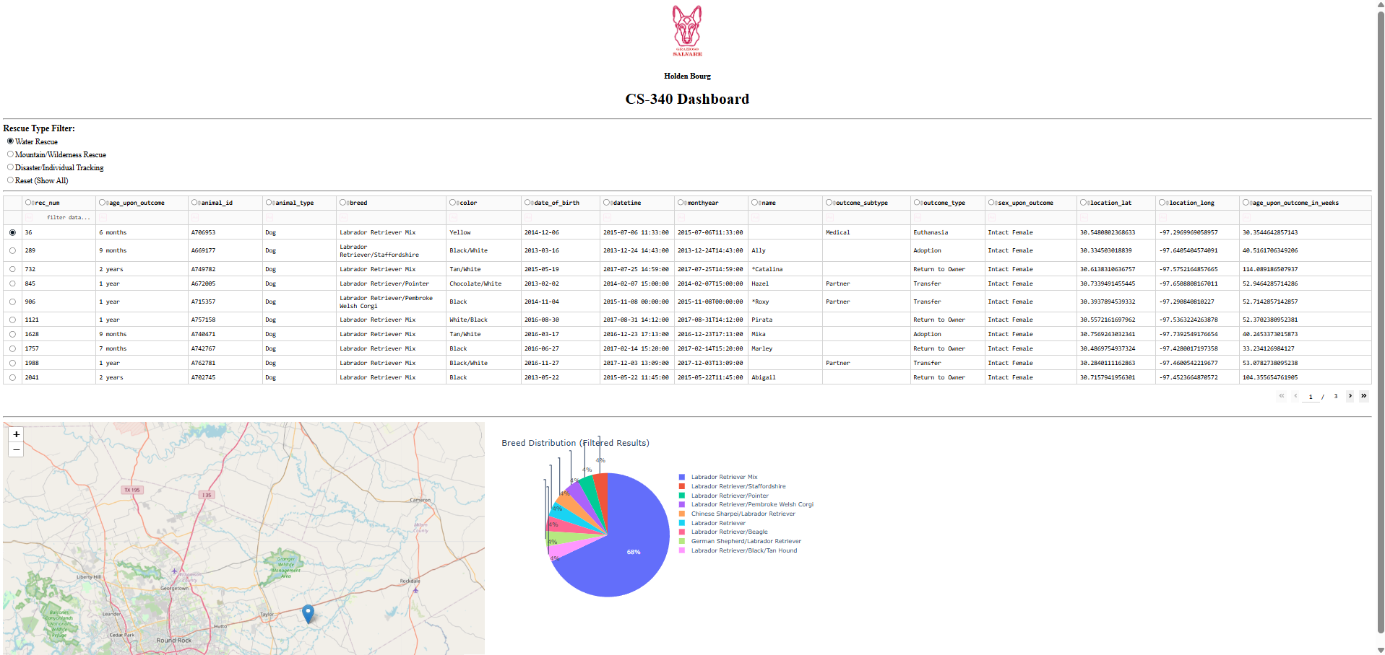

When Mountain /Wilderness Rescue is selected:

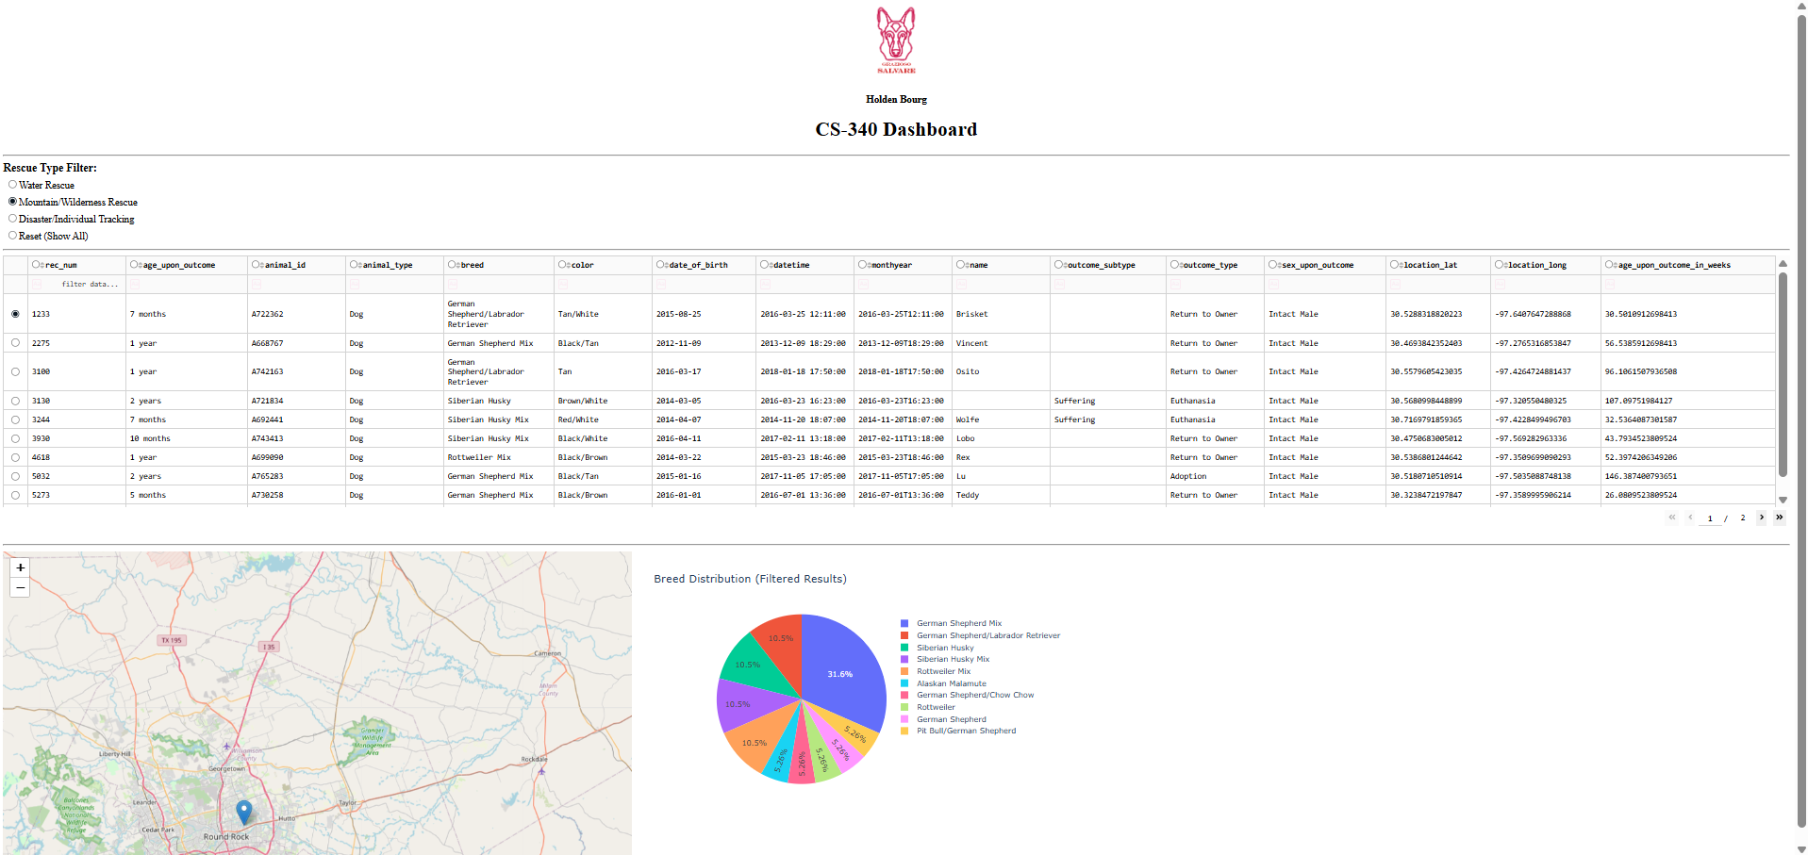  
When Disaster/Individual Tracking is selected:

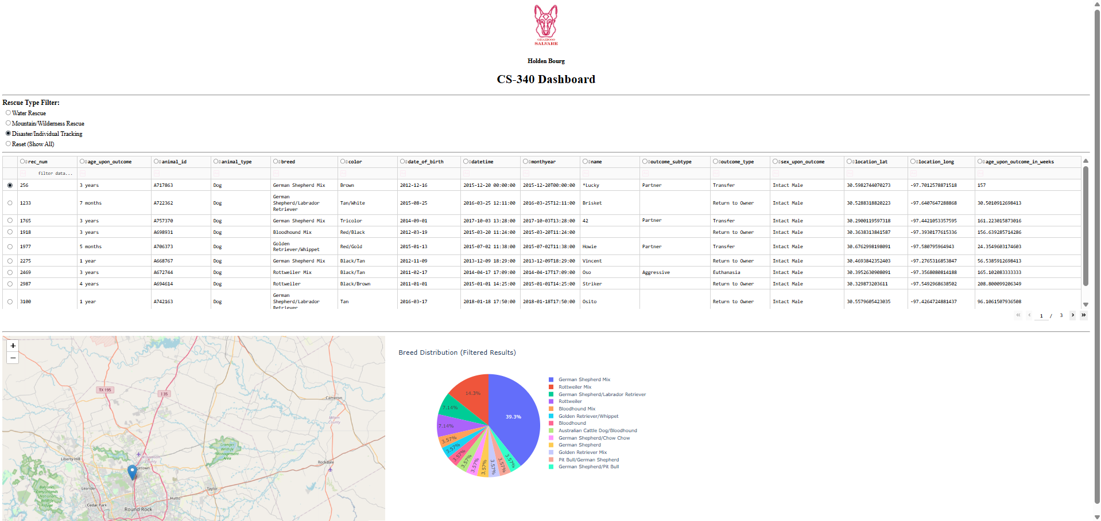

We built this project using MongoDB, Python, and Dash. We chose MongoDB because it stores data in flexible JSON-like documents and is very friendly with Python via PyMongo, making it easy to run queries and load results into Pandas. We used the Dash framework to build the interactive web dashboard in Python, helping provide the view and controller functionality, letting us not have to use HTML or JavaScript.

Steps we took to complete this project:

1. Connected MongoDB and built a CRUD Python module to communicate
2. Loaded records into a Pandas DataFrame and displayed them in a Dash DataTable
3. Added filter controls for the three rescue types
4. Created a pie chart (using Plotly) and a geolocation map (using Dash Leaflet)

Didn’t run into any issues during the project that I couldn't fix relatively quickly with research.